Classification of Natural Numbers into prime and Gaussian prime using Multilayered Perceptron

Nathan Hall
Computer Science
Missouri State University
Springfield, MO USA
Hall257@live.missouristate.edu
Rohan Saha
Computer Science
Missouri State University
Springfield, MO USA
rohan2728@live.missouristate.edu

Abstract — Prime numbers are an area of interest to both mathematics and information security. This paper will attempt to demonstrate how a mult-layer perceptron (MLP) can be implemented to predict whether a number, given its results to certain primality/composite tests, is prime, with an accuracy of, or near, one-hundred percent.
Keywords—prime numbers, multi-layer perceptron, primality

Introduction
Prime numbers are not just a mathematical curiosity. They can be represented in the real-world. Take for example 7 people who want to play a game. There is no way to split the seven people into equal size teams, except all on 1 team, or 7 teams of 1 player each.
Many think of prime numbers as only being members of the natural numbers, but mathematicians hold that the negative counterparts are also primes. For many cases, the sign of the prime is irrelevant, so for this paper we will only be dealing with the non-negative primes.
Prime numbers have a long history. One of the earliest methods to determine prime numbers is the Sieve of Eratosthenes [1], where given an index n, the sieve method will find all prime numbers up to the given index. The method is deterministic and has an approximate run-time of 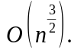Since it is sub-quadratic run time, this is pretty good. The drawback is that it starts from scratch each time, and to reach record large primes will take a large amount of computer resources and/or time. This has led mathematicians to derive many formulas and tests, some based on their unique properties, to either find or predict prime numbers. Although, these formulas and tests can lead to false outcomes, known as pseudo primes.
Fast forwarding through time, we find the modern world depending on prime numbers for a range of security needs. From online transactions and banking, to secure communication, prime numbers are crucial to preventing unwanted and/or unauthorized access to personal and government information.
This paper attempts to capitalize on the work done by many people, across time, to form an ensemble of tests, take those results, feed them into an Multi-Layer Perceptron (MLP), and try to accurately identify whether the number used in the tests, is a prime or composite.

Primality Tests

General Algebraic Property of Primes
The first attribute we will discuss is a simple property that all prime numbers have. All primes greater than 3, can be written in the form 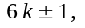where k is any integer. The proof of this will be left to the reader. For our purposes, this implies that given a prime p, 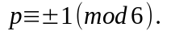Therefore, we will be using mod 6 as an attribute.

Selfridge Conjecture
The Selfridge Conjecture [2], also known as the PSW Conjecture, has two conditions that need to be met, prior to being subjected to the algorithm of primality testing. For our purposes, we have ignored the first two conditions, and have every number tested. The algorithms used to test are 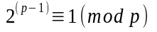and 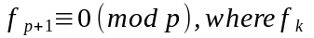 is the kth Fibonacci number.
The first test is a simple use of Fermat’s Little Theorem, 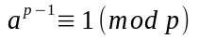, using base 2.
A note of warning. There is a closed form formula to calculate the nth Fibonacci number, which is 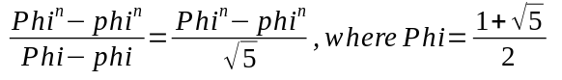 and 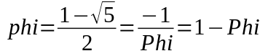. As you can see, it is an exponential function, which can lead to overflow. With a closer look, we found that the python 3 language, due to rounding, the formula stops accurately returning Fibonacci numbers at 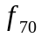. Therefore, generating the recursive sequence is preferred. This shows it suffers from the same defect of that the Sieve of Eratosthenes does. For this reason, in future analysis, it will be desired to be removed from the list of attributes of the MLP.

Baillie-PSW
The Baillie-PSW [3] test is akin to the Selfridge Conjecture, with the primary difference of using Lucas numbers instead of Fibonacci numbers. The Lucas numbers has the same implementation drawbacks as mentioned before, concerning Fibonacci numbers, and this too will be analyzed in context of attribute removal.

Multilayer Perceptron (MLP)
A multilayer perceptron (MLP) is a class of feedforward artificial neural network. An MLP consists of at least three layers of nodes. Except for the input nodes, each node is a neuron that uses a nonlinear activation function. MLP utilizes a supervised learning technique called backpropagation for training.[11][12] Its multiple layers and non-linear activation distinguish MLP from a linear perceptron. It can distinguish data that is not linearly separable.[13]
Feedforward networks such as MLPs are like tennis, or ping pong. They are mainly involved in two motions, a constant back and forth. You can think of this ping pong of guesses and answers as a kind of accelerated science, since each guess is a test of what we think we know, and each response is feedback letting us know how wrong we are.
In the forward pass, the signal flow moves from the input layer through the hidden layers to the output layer, and the decision of the output layer is measured against the ground truth labels.
In the backward pass, using backpropagation and the chain rule of calculus, partial derivatives of the error function w.r.t. the various weights and biases are back-propagated through the MLP. That act of differentiation gives us a gradient, or a landscape of error, along which the parameters may be adjusted as they move the MLP one step closer to the error minimum. This can be done with any gradient-based optimization algorithm such as stochastic gradient descent. The network keeps playing that game of tennis until the error can go no lower. This state is known as convergence.
Figure 1 shows the basic architecture of the MLP. The left most layer, known as input layer consists of set of neurons {x_{i} | x₁ + x₂ + x₃ +… x_{n}}, each neuron in the input layer receives the input data and passes to the next layer which is known as the hidden layer. The neurons in the hidden layer is associated with a weight value. This weight value shows gives an importance to each neuron, for example if neuron x₃ is really important as a input attribute then the weight value for node a₃ in the hidden layer will have much greater weight than the other neurons . Each neuron in the hidden layer is also associated with an activation function, these functions does some processing to the input node. The activation function is applied to the dot product of the input value and the weights into a node to produce an output. A bias value is usually added to indicate that the activation function is applied or the node fires if the value of
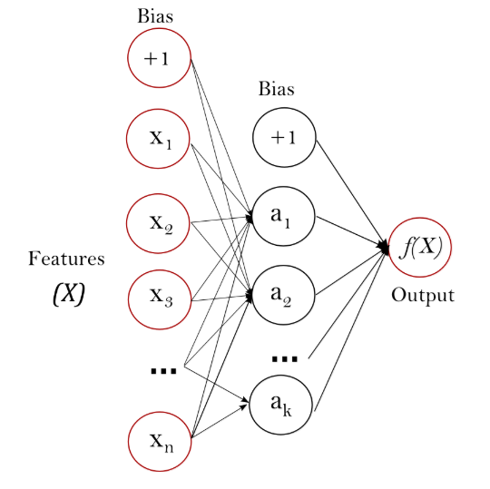
Figure 1. Basic Architecture of MLP

Reference

- K. Rosen, Elementary Number Theory, 5th ed., Pearson, 2005, pp. 70.
- Wikipedia, https://en.wikipedia.org/wiki/John_Selfridge#Selfridge%27s_Conjecture_about_Primality_Testing
- Wolfram MathWorld, http://mathworld.wolfram.com/Baillie-PSWPrimalityTest.html
- G. Eason, B. Noble, and I. N. Sneddon, “On certain integrals of Lipschitz-Hankel type involving products of Bessel functions,” Phil. Trans. Roy. Soc. London, vol. A247, pp. 529–551, April 1955. (references)
- J. Clerk Maxwell, A Treatise on Electricity and Magnetism, 3rd ed., vol. 2. Oxford: Clarendon, 1892, pp.68–73.
- I. S. Jacobs and C. P. Bean, “Fine particles, thin films and exchange anisotropy,” in Magnetism, vol. III, G. T. Rado and H. Suhl, Eds. New York: Academic, 1963, pp. 271–350.
- K. Elissa, “Title of paper if known,” unpublished.
- R. Nicole, “Title of paper with only first word capitalized,” J. Name Stand. Abbrev., in press.
- Y. Yorozu, M. Hirano, K. Oka, and Y. Tagawa, “Electron spectroscopy studies on magneto-optical media and plastic substrate interface,” IEEE Transl. J. Magn. Japan, vol. 2, pp. 740–741, August 1987 [Digests 9th Annual Conf. Magnetics Japan, p. 301, 1982].
- M. Young, The Technical Writer’s Handbook. Mill Valley, CA: University Science, 1989.
- Rosenblatt, Frank. x. Principles of Neurodynamics: Perceptrons and the Theory of Brain Mechanisms. Spartan Books, Washington DC, 1961
- Rumelhart, David E., Geoffrey E. Hinton, and R. J. Williams. "Learning Internal Representations by Error Propagation". David E. Rumelhart, James L. McClelland, and the PDP research group. (editors), Parallel distributed processing: Explorations in the microstructure of cognition, Volume 1: Foundation. MIT Press, 1986.
- Cybenko, G. 1989. Approximation by superpositions of a sigmoidal function Mathematics of Control, Signals, and Systems, 2(4), 303–314.

